Was the First Craniate1 on the Road to Cognition?
A Modern Craniate’s Perspective

Evolution and Cognition 2003, 9(2): 142-156

Fredric J. Heeren

Abstract Chinese fossil discoveries of the earliest known craniates (from the early Cambrian period) have led scientists to question whether the evolution of human-level cognition is a rare occurrence in the universe. The earliest chordate is now best represented by a well-documented metazoan called Haikouella lanceolata. Possessing a relatively large brain, this animal appears to demonstrate that the brain and endoskeleton did not evolve together, as had been assumed, but rather that the brain appeared long before full endoskeletization. The paleontologist who describes the animal further notes a “top-down” pattern in the appearances of new forms in the fossil record. Researchers find such observations relevant to the question: Was the evolution of human-level cognition in some sense inevitable, or was it an accident dependent upon historical contingencies? The new evidence for early craniates lends support to the view that human- level cognition may be part of a developmental package, but historical contingencies pose serious problems for a strictly law-like explanation.

Key words Contingency, convergence, developmentalism, directionality, internalism, saltation, top-down evolution.

One might propose three mutually exclusive hypotheses to explain the existence of human- level cognition 2 observed on Earth:
1. Human-level cognition occurs as a fluke in the universe; on Earth it may be explained as an incidental result of highly contingent events. 3
2. Human-level cognition is a common occurrence throughout the universe; its existence on Earth may be explained as a result of highly constrained or law-like processes.
3. Human-level cognition on Earth can be explained as neither fluke nor the result of law-like processes; 4 the frequency of its occurrence in the universe may not be predictable.

An investigator who knew that hypothesis 1 or 2 was correct would be able to comment knowledgeably upon the probability of human-level cognition existing on any planet where signs of life were observed. To estimate the probability of human-level cognition on such a planet, a scientist might only need to know the length of time that the planet had sustained conditions for life. Ideally, an investigator attempting to choose between the above hypotheses should observe life at several stages on many habitable planets before claiming confidence in his selection. Of course, the best an Earthbound scientist can do at present is to search for helpful clues on the one planet where we know that life exists; and here at least Earth’s crust does provide helpful access to pertinent glimpses of past life stages. Of greatest relevance for any such researcher is the fossil record’s snapshot in which the body plan 5 first appears that would eventually house human-level cognition.

To join such an investigation, we would like to explore the following questions: When does this body plan appear relative to other body plans? Does this body plan have an assured, or at least a likely, survival to permit time for the evolution of cognition—or is the survival of its future lineage dependent upon highly contingent events? Do other body plans appear that would also seem to make good candidates for the support of human-level cognition? How predictable is the appearance of a suitable, large brain-carrying body plan? For that matter, upon what basis can we predict body plans at all, or changes in any form of life? Does evolution proceed in a bottom-up fashion where small changes accrue into large ones aided by no higher law than natural selection, or are there top-down forces at work, driving organisms more forcefully toward obligatory forms?

Examining these questions takes us back to the early Cambrian period, to the time, 530 million years ago, when virtually all the major animal groups, called phyla, first appear in the fossil record. In December 1999, the journal Nature announced the discovery there of what appears to be the remains of our earliest chordate ancestor (CHEN /HUANG /LI 1999a). Found in southern China’s Yunnan Province near Kunming, the stiffspined, paper clip-size animal named Haikouella lanceolata pushes back the evolution of our own phylum, Chordata , to the very start of modern metazoan life. Until its discovery, paleontologists had begun to despair of ever finding undisputed evidence that our own “advanced” phylum existed as early as the main burst of the Cambrian “explosion” of new body plans. The plentiful fossil evidence for Haikouella— 305 specimens, many in excellent condition—finally confirms what many had suspected in recent years: Our own phylum arrived on the scene along with most of the others, during the surprisingly quick radiation of new major animal groups that characterizes the early Cambrian period.

The discovery demonstrates that our chordate ancestors had to fight their way through the rough and tumble Cambrian seas, in a period when many animal groups that entered did not survive to the end. Most families—and even many whole body plans—disappeared (GOULD 1989, pp47n; WARD 2000, p184). As we detail below, many paleontologists further classify Haikouella as a craniate. Any argument for the inevitability of craniate survival could be made more confidently if this body plan had arisen after the Cambrian, since the Cambrian represents the only period in which the number of animal phyla actually decreased (Dobzhansky et al. 19 77, pp. 422–423; SOLÉ /GOODWIN 2000, pp. 249– 251). Thus, as we will see, the appearance of the craniate body plan in the early Cambrian has paradoxical implications for a heady future; it can be taken either as evidence for a head start on the pathway to intelligence, or evidence of heightened probability that this lineage would be cut off—at its head. Haikouella simultaneously creates support for two competing inferences: the evolution of cognition as a highly constrained, or as a highly contingent, process.

Current Controversies
The animal’s discovery thus raises questions at the heart of current controversies in evolution research. One of the broadest ways to characterize the competing positions is as a disagreement between externalists and internalists, i.e., those who treat external selection as virtually the sole creative force in evolution versus those who emphasize the importance of internal constraints. Related issues tend to pit developmentalists against neo-DARWINISTS , formalists against functionalists, punctuationalists against gradualists, and top-down theorists against bottomup theorists, with the first party in each pair siding with the internalists. 6

Perhaps the most profound movement in the field in recent decades has been the advancement of developmental biology (which studies the way genes control the growth of individual living organisms) as a key to evolutionary biology. Since the mid-1990s, the marriage between the two disciplines has become known as evolutionary developmental biology, or simply “evo-devo”. Evo-devo explores how changes in ontogeny (the development of individual organisms, from fertilized egg to maturity) are related to the emergence of new phenotypes over successive generations. The goal is to use knowledge of how genes control the development of embryonic structures to learn how these same genes were involved in the first appearance of such structures in past epochs. Early contributors to the field include DE BEER (1930), SCHMALHAUSEN (1949), WADDINGTON (1957), RAFF /KAUFFMAN (1983), ARTHUR (1988), and HALL (1992). Developmentalists believe that too much credit has been given to the power of natural selection.

Wallace ARTHUR finds it “strange … that mainstream neo-DARWINIAN theory has come to regard natural selection as the primary mechanism causing evolutionary change. Selection is a destructive force, which acts only to eliminate” (ARTHUR 1997, p241). Though trained as a neo-DARWINist, ARTHUR acknowledges that selection “does not create the new type in the first place”, adding: “We have come to accept a theory of evolution that explains the origin and diversification of exquisitely engineered organisms on the basis of the selective destruction of genetic/developmental variants whose initial production has been treated, for the most part, as a ‘black box’” (Ibid). When it comes to the origin of body plans, according to ARTHUR , explaining it “purely in selective terms, without reference to the underlying genetic architecture will ultimately fail. Hence the need for the new discipline of evolutionary developmental biology” (p. 291).

Harvard zoologist Stephen Jay GOULD , who died in 2002, noted that DARWIN himself had not believed that natural selection was the exclusive means of evolutionary modification. Nevertheless, he said, certain “ultra-DARWINISTS ” were trying to “out-DARWIN DARWIN ” by claiming “that natural selection regulates everything of any importance in evolution” (GOULD 1997). For their part, neo-DARWINISTS accused G OULD of wandering too far from the reductionism 7 so necessary to science’s success. Daniel DENNETT even suggested that GOULD must have had a “hidden agenda” to sneak purpose back into biology (DENNETT 1996). The accusation was patently false; GOULD never wrote with any such intent; in fact, he went to great lengths to create new terms to replace any that smacked of teleology. “Preadaptations” became “exaptations” precisely to avoid the teleological overtones; “saltation” and “laws of form” became “facet-flipping” (GOULD 2002, pp342– 351), helping to assure that the element of chance overshadowed any Platonic connotations.

In his last monograph , GOULD wrote: “I argue that ‘internalism’ poses two separate challenges to pure DARWINIAN functionalism: saltational change arising from internal forces of mutability, and inherent directionality of variation… Most internalists … emphasize the second theme of channels and preferred directionality of variation” (2002, p445). One of the traits that made GOULD stand out from other internalists was his emphasis on chance. He seemed intent to exonerate himself from any charge of advocating teleology by assuring us that, though constraints have their important place, stochastic events have the final word. Our own existence is attributable to a “golden happenstance” in the Cambrian explosion (p. 1159), the start of an unlikely course that continued with the repeated overcoming of odds to produce humans as “an ultimate in oddball rarity” (1996–1997). If the developmental patterns of bilaterians appear to have become fixed into “limited and excellent, perhaps even optimal, designs”, it is only because they represent just one possible solution among numerous entirely plausible alternatives of strikingly different form, each yielding a subsequent history of life entirely different from the outcome actually experienced on earth” (2002, p1159). Yet all who support development’s importance to evolution (including GOULD , who used terms like “directionality” and “congealed designs”) must support the concept of directionality, however they explain it.

ARTHUR uses the term “directionality” to describe the observation of large-scale evolutionary changes preceding smaller modifications, “big ‘experiments” giving way to progressively more restricted modifications” (ARTHUR 1997, p207), i.e., the top-down concept that we will explore below. He writes: “This idea of directionality—which is absent from conventional neo-DARWINIAN theory —is important in Evolutionary Developmental Biology” (Ibid).

Against this background, we can now return to the findings about the earliest known craniate, to note the support they yield for this article’s first two hypothetical options: human-level cognition as either fluke or common occurrence. We can also compare the support they afford straightforward neo- DARWINISM versus developmentalism.

A listing of Haikouella -related supporting evidence for developmental constraints—and the ubiquity of human-level cognition in the universe —could read as follows: 1) early priority of cephalization over endoskeletization, 2) constraints/convergence/channeling, 8 3) hierarchical phylogenies, 4) saltation, 5) top-down pattern in the fossil record, and 6) the principle of mediocrity.
Supporting arguments for contingency—and the rarity of human-level cognition in the universe— would include: (1) The appearance of craniates in the early Cambrian (the one period where the number of phyla decreases) greatly increases the probability that this lineage would become extinct; (2) Non-chordate phyla can be shown to be incapable of developing human-level cognition; and (3) Human-level cognition has evolved only once on this planet.

As we recount the findings reported by Haikouella’s investigators, we will examine each of these in turn.

Settling the Matter of Chordates in the Cambrian
Before Jun-Yuan CHEN ’s discovery of Haikouella (CHEN /HUANG /LI 1999a; CHEN /HUANG /LI 1999b) (Figures 1 and 2), it was beginning to look doubtful that Cambrian chordates would ever become firmly established. Each new interpretation of the mostly poorly preserved would-be-chordate specimens was hotly disputed.

Biologists belonging to the contingency camp, as opposed to those expecting directionality, would have settled for an extremely primitive-looking chordate or half-chordate. Champions of chance expected the earliest chordate to exhibit brawn before brains; they sought the distinguishing chordate feature of muscles arranged in V-shaped blocks (called myotomes) without expecting to find much of a head at first. Even more essential for an earliest chordate candidate is the notochord, from which chordates get their name. The notochord is a stiffening, muscularized rod that runs down the middle of the back. The head was seldom mentioned except in reference to things to come, and never as an essential element for the earliest chordate. To illustrate what the earliest chordate should look like, biologists chose amphioxus, an animal that appears headless and pointy at both ends, as the most plausible living model. The name “amphioxus” literally means “both [ends] pointed”.

The first generally recognized evidence for possible chordates in the Cambrian came to light almost a quarter of a century ago, when Cambridge paleontologist Simon CONWAY MORRIS tentatively promoted a middle Cambrian species called Pikaia from annelid worm to chordate status (CONWAY MORRIS / WHITTINGTON 1979). Stephen Jay GOULD saved the tiny, simplified eel-shaped animal for the climax of his popular book about Canada’s Burgess Shale animals. On the last pages of Wonderful Life, he called Pikaia “the missing and final link in our story of contingency —the direct connection between Burgess decimation and eventual human evolution” (GOULD 1989, p322). Since then, however, less enthused scientists have questioned Pikaia’s chordate classification because of its lack of chordate features like gills, gonads, and a full notochord (HOLLAND personal communication).
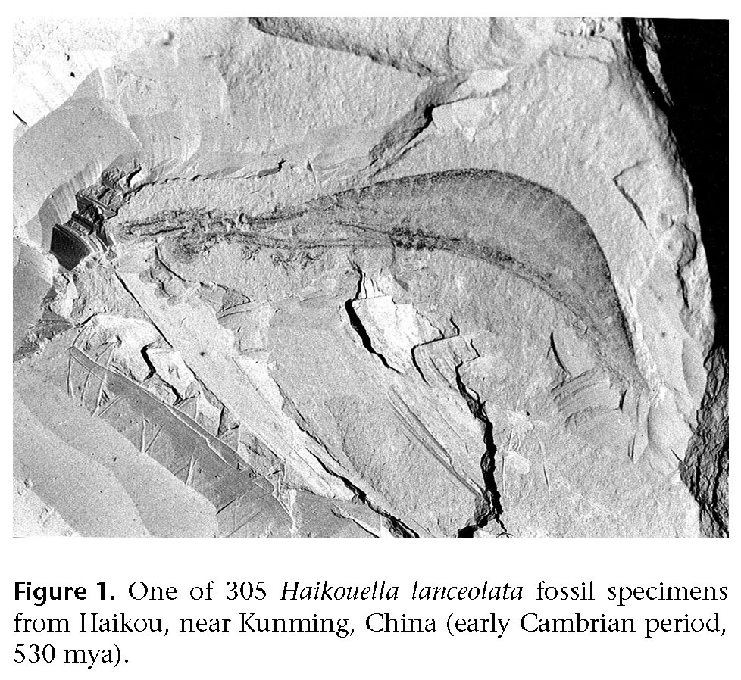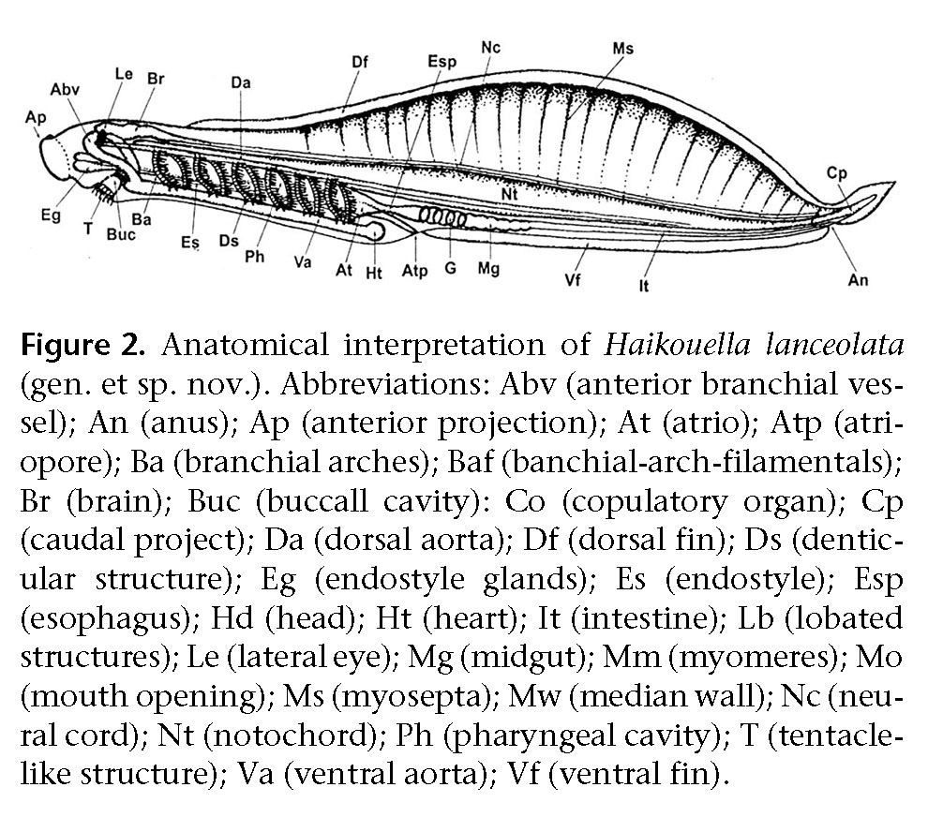

For GOULD, the middle-Cambrian Pikaia best fit what the earliest chordate should look like: simple, sleek and headless. He mentions no brain, eyes, or other sensory organs when describing Pikaia in his popular book; even the possibility of a head seems remote in an animal whose anterior end, in his illustration, splits into two (GOULD 1989).

The next best hope came from animals whose chordate status was disputed or who appeared too late to show that chordates joined in the early Cambrian radiation of new forms. The eel-like conodont, long known only from its teeth, extended back only to the late Cambrian (PURNELL/DONOGHUE 1997). During the 1990s battles ensued over descriptions of two new chordate claims represented by just a few specimens: Yunnanozoon (CHEN et al. 1995) and Cathaymyrus (SHU/CONWAY MORRIS/ ZHANG 1996). The discoverer of Cathaymyrus thought Yunnanozoon looked more like a hemichordate (acorn worm) than a chordate (SHU/ZHANG/ CHENG 1996); and the discoverer of Yunnanozoon opined that his challenger had mistaken Cathaymyrus’s squashed dorsal fin for a notochord (CHEN/ HUANG/LI, 1999b).

After the Cambrian waters had been sufficiently muddied, researchers wondered if any true chordate had ever been found in Cambrian strata. Maybe our own “sophisticated” phylum had not yet evolved. Even GOULD’s Pikaia, though used to illustrate Cambrian chordates in vertebrate textbooks, no longer looked convincing, since it lacked many of the chordate features claimed by the more recent finds.

Thus the significance of the discovery of Haikouella —displayed in over 300 specimens. In CHEN’s description of Haikouella fossils, he pointed out features that not only demonstrate its chordate status, but that shed light on the origin of craniates (biology’s new name for vertebrates) (CHEN/HUANG/LI 1999b). The new nomenclature reflects a new primary diagnostic feature for this taxon: a distinct head enclosing a brain and sensory organs, recognizing that this character should now take precedence over the presence of a vertebral column.

Known for his research on amphioxus, the present-day animal thought to best represent the ancestor of all vertebrates, Nicholas HOLLAND said: “There’s no question these things are chordates” (ENSERINK 1999). He remarked on the great number of specimens with conspicuous gill slits (for straining food out of the water) and other diagnostic characters: “The muscle segments are unarguable, and the notochord’s good too” (HOLLAND 1999). Unlike specimens from other recent finds, both Haikouella and Yunnanozoon exhibit large notochords that clearly run the full length of their bodies. “It’s the earliest known chordate ancestor”, said HOLLAND. “Every zoology student and every paleontology student for many, many generations is going to have to look at that picture. This is going to be page one, two, three and four of vertebrate texts, and paleontology texts, and invertebrate zoology texts” (HOLLAND personal communication).

Since the discovery of Haikouella, Degan SHU et al. (1999) reported their discovery of two new chordates, Myllokunmingia and Haikouichthys, each based on a single specimen. Collaborator Simon CONWAY MORRIS proposes that the animals had skulls made of cartilage (MONASTERSKY 1999). CHEN notes that the specimens display two important features: distinctive fins (large dorsal and possibly paired ventral fins) and zigzag-shaped segmented muscles, similar to the pattern in modern fish (CHEN, personal communication). Though paleontologists of these various discoveries continue to contend with one another over whose specimens are ancestral to whose—and whose are true chordates—all agree that chordates have now been found in the early Cambrian (ENSERINK 1999; DZIK 1995).

What will happen to GOULD’s Pikaia, the animal zoology textbooks presently tout as our earliest chordate ancestor? HOLLAND contends that the textbook writers had no business picking up Pikaia as a chordate ancestor from GOULD’s popular book, since GOULD was not an authority on the animal (HOLLAND personal communication). GOULD had simply made it fit what he needed to relate the Burgess Shale fauna to humans. “Why do humans exist?” asked GOULD on the last page of Wonderful Life. “A major part of the answer, touching those aspects of the issue that science can treat at all, must be: because Pikaia survived the Burgess decimation” (GOULD 1989, p323). GOULD had used Pikaia to relate Pikaia to us and us to his overriding theme: contingency. “What this conference has done”, said HOLLAND at the symposium where Haikouella was announced, “is to pull the rug out from under Pikaia, for sure. Nobody will ever talk about it again” (HOLLAND personal communication).

Shedding Light on Vertebrate Origins
Now that lower Cambrian chordates have been con- firmed, zoologists must deal with the fact that Haikouella —and other early Cambrian chordates—look nothing like what they expected to see in a predecessor of Pikaia. Rather than finding evidence that this complex animal had less sophisticated ancestors, CHEN and SHU instead found examples of more complex, fully formed chordates—fifteen million years earlier. None of these newly discovered chordates have vertebrae or endoskeletons, so strictly speaking, they aren’t vertebrates. But displaying relatively large brains, these animals appear to be in the line to vertebrates, so that at the conference where Haikouella was announced, the strange term “pre-backbone vertebrate” was frequently bandied about. The brain’s early appearance would seem to demonstrate that brain and endoskeleton did not evolve together, as had been assumed, but rather that the brain appeared long before the development of the vertebrate spine.

“The discovery of the first craniate shows that the evolutionary history toward vertebrates had been on track long before the origins of the backbone”, says Taiwanese biologist Chia-Wei LI ( 1999), co-author of the Haikouella description. Haikouella findings run counter to the commonly held notion that the head could not become the dominant body structure until the body’s superstructure was also in place. It now appears that, against externalist expectations, cephalization (when the head became the dominant or controlling body structure) preceded endoskeletization (the development of an internal support structure).

CHEN also identified other important features in Haikouella that preceded the development of a bony skeleton: a neural cord that, like the notocord, runs the length of the body; a heart; a pair of lateral eyes; and tiny teeth. The teeth are located far back in its large pharyngeal cavity rather than in the mouth, indicating that it used them for grinding, not biting. Biologists had assumed that chordates did not develop the ability to accumulate minerals in their bodies to form teeth or bones until about 500 million years ago. But Haikouella and Yunnanozoon demonstrate that biomineralization had begun at least 30 million years earlier. Teeth led the way long before the development of a notochord-protecting, mineralized vertebral column or other bones.

Constraints, Channeling, and Convergence
The sudden explosion of widely disparate Cambrian animal Bauplans, followed by no new body plans throughout the rest of geologic history, fits the picture of a constrained process, the channeling of changes within particular forms. Scientists also find evidence of constraints today in the form of parallelism and convergence,9 both in experiments with living animals and in theoretical modeling. From his research on the development of amphibians, brain researcher Gerhard SCHLOSSER notes trends “where several characters tend to act as a ‘unit of evolution’, i.e., they tend to coevolve repeatedly” (SCHLOSSER 2000).

Evolutionary geneticist Paul RAINEY and his colleagues have also noticed convergence in evolution while experimenting with the bacterium Pseudomonas fluorescens. “These experiments in test-tube evolution”, says RAINEY, “allow us to replay life’s tape, albeit on a small scale, as often as we like” (RAINEY 2003). Their findings? “Evolution repeats itself”. By growing rapidly diversifying strains of the bacterium in test tubes of nutrient broth, they have discovered that “in the face of similar selective conditions, different lineages can find similar solutions to the same problems”. RAINEY is not afraid to find implications from his findings for human evolution: “Replay life’s tape”, he claims, “and while Homo sapiens may not evolve there is a high probability that introspective bipedal organisms with binocular vision will” (Ibid).

Simon CONWAY MORRIS reaches a similar conclusion. Speaking of the property of consciousness, he writes: “Here the reality of convergence suggests that the tape of life, to use GOULD’s metaphor, can be run as many times as we like and in principle intelligence will surely emerge” (CONWAY MORRIS 1998, p14). What about “the numerous entirely plausible alternatives of strikingly different forms” that GOULD expected if the tape should be rerun from the beginning? “Put simply”, says CONWAY MORRIS, “contingency is inevitable, but unremarkable…. There are not an unlimited number of ways of doing something. For all its exuberance, the forms of life are restricted and channeled” (p13). CONWAY MORRIS believes that convergence “effectively undermines the main plank of GOULD’s argument on the role of contingent processes in shaping the tree of life” (Ibid). GOULD, he says, “presupposes that constraints are weak” and makes a “most egregious misinterpretation of the Burgess Shale” (CONWAY MORRIS 1998–1999). His “egregious misinterpretation” —contingency as the major lesson of the Burgess Shale—is a conclusion that GOULD drew from his personal credo, according to CONWAY MORRIS, not from paleontology (Ibid).

Hierarchies
Cladistics, a branch of biology that does indisputably draw its evidence from paleontology, hypothesizes relationships between organisms according to shared derived characters (synapomorphies). The distribution of these diagnostic features forms a set of nested groups (clades), in which smaller clades are contained within larger ones. The hierarchic pattern that has become the hallmark of cladistic analysis is related to the lack of transitional forms found between groups. DARWIN expected evolution to leave us with surviving modern groups within groups, but he expected the history of life to proceed in a gradualistic sequence that blurs the lines between groups. The scarcity of such fossil transitions can only be explained in DARWINIAN terms as a sampling problem, an artifact of an incomplete fossil record (DARWIN 2000, p292). Modern paleontologists generally agree, however, that the fossil record is actually robust enough to tell us that the scarcity of transitional forms is real and significant (SIMPSON 1960; GOULD 1977; VALENTINE/ERWIN 1987; DONOVAN/ PAUL 1998; FOOTE 1996; FOOTE/SEPKOSKI 1999), making the hierarchic pattern a genuine aberration in the gradualistic picture.

The priority of typology over continuity has persisted, according to SIMPSON, among “all schools of taxonomy including some that usually oppose typology in principle” (SIMPSON 1961, p49). Haikouella contributes to this crystalizing picture of distinct, fully formed body plans from near the start. Developmentalists observe the same hierarchical processes at work in both ontogenesis and evolution. Biologist Brian GOODWIN writes: “Developmental processes are hierarchical. So are biological classification schemes” (GOODWIN 1994, p234). Wallace ARTHUR agrees: “A theme running through the work of most contributors to what can now be described as evolutionary developmental biology is the relationship between these two hierarchies”, (ARTHUR 1997, p256) and he asserts that “it is informative about the nature of evolutionary mechanisms” (p257).

Saltation
How much further back can we trace our ancestors? Nicholas HOLLAND, for one, wants to know what preceded these complex, early Cambrian craniates, a question, he says, that remains as big a mystery as ever: “Where are Haikouella’s ancestors? The sixtyfour dollar question is, What is this hooked to? That nobody knows” (HOLLAND personal communication).

In his presentation to an international symposium on Cambrian body plans (1999), HOLLAND gave genetic reasons why the most popular theoretical predecessor for chordates, tunicates (sea squirts), only works in the imagination of the theorists. When chordates are compared genetically with tunicates and fruit flies, he says, “the fruit fly is closer to the tunicate every time” (HOLLAND personal communication).

No obviously ancestral fossils presently exist to support theories about how chordates, or the other phyla, evolved in Precambrian times. “There are a lot of different totally cutup paper doll ideas about where things come from that aren’t based on fossils at all, but people sitting in their armchairs”, says HOLLAND (personal communication). The ceaseless re-interpretation of ancestral lineages for the phyla is easily demonstrated by the relevant literature (ARTHUR 1997, p73; BERGSTRÖM 1994; LYNCH 1999). Wherever the first chordates came from, HOLLAND thinks science must now take seriously the concept of “saltation”, the possibility of evolution in quick jumps. However broadly one defines “saltation”, paleontological evidence for the notion is certainly supportive of the internalist/developmentalist position.

Though opinions vary about the Precambrian antiquity of the phyla, all agree that almost all of these most widely separated animal groups had appeared by the early Cambrian period. Why didn’t new phyla continue to evolve during subsequent eras? Why did such disparate phyla as chordates, mollusks, arthropods, and the 35-or-so others first show up in the fossil record so close to the same time? CHEN places the window of opportunity for the explosive evolution of the majority of body plans within a narrow window of three million years (CHEN 1999), though of course, this is hotly disputed.

Body plans seen in the Precambrian include sponges, annelid worms, and echinoderms (like sea stars), but little else to represent the many lineages expected to lead to the 35 Cambrian groups. Gradualists have claimed that the ancestors of the many other disparate Bauplans must have been too small or too soft to be preserved. But since 1998, phosphate deposits at a Precambrian locale called Weng’an have proved capable of preserving the smallest and softest organisms imaginable (LI et al. 1998). Sponge embryos have been found by the thousands in early cleaving stages, seen under the microscope in groups of 2, 4, 8 cells, etc. (Figure 3). Though small and soft specimens are found in abundance, the number of body plans remains small.

The questions raised by such findings drew sixty scientists to Kunming, China, for a symposium entitled: “The Origins of Animal Body Plans and Their Fossil Records”. Perhaps it took the discovery of our own phylum’s participation in the early Cambrian big bang to bring together such an international gathering to consider a pattern some call “top-down evolution”.

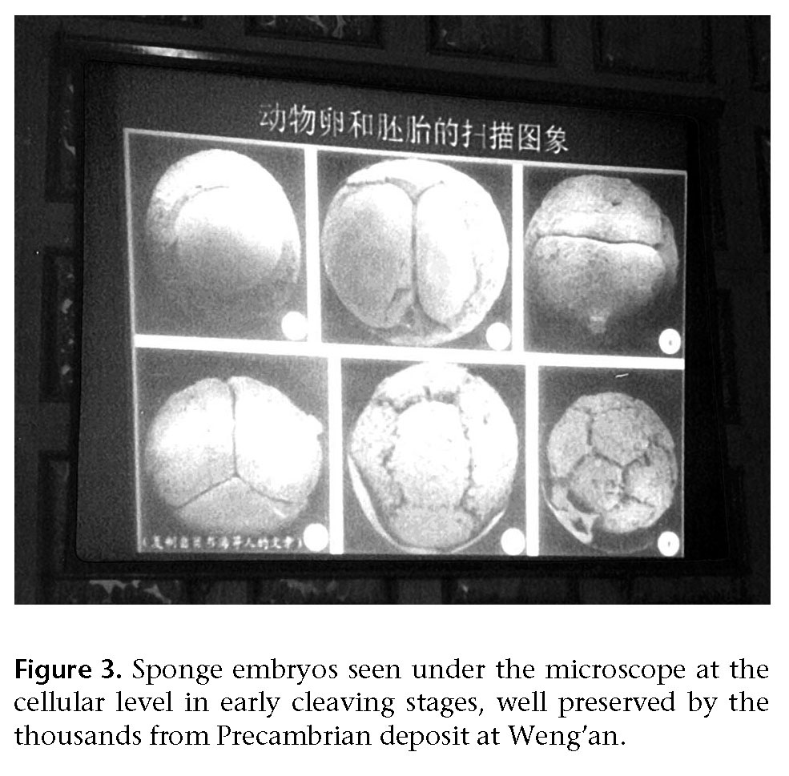

Top-Down Evolution
The appearance of chordates at this early date adds to the evidence for what Berkeley paleobiologist James VALENTINE and his colleagues call a “topdown” pattern in the fossil record (ERWIN/VALENTINE/ SEPKOWSKI 1987). In the most published diagram in the history of evolutionary biology (and the only diagram in On the Origin of Species), DARWIN illustrated what became the standard, bottom- up view of how new taxa evolve (DARWIN 2000, pp514–515). Beginning with small variations, evolving organisms diverge further from the original ancestor, eventually diversifying into new species, then new genera, new families, new orders, and the splitting continues until the highest taxa are reached, which are separated from one another by the greatest differences (DARWIN, p120, p128; SIMPSON 1953, pp383–384).

“The textbooks all teach that evolution takes place when a new species appears, when the morphology is very close”, said CHEN in a talk titled “Top-Down Evolution and the Fossil Record” (CHEN 1999). “But that story is not true, according to our fossil finds”, he told the assembled scientists. “The new phyla make their start in the early days, instead of coming at the top”. He pointed to a very different-looking diagram of his own to illustrate the fact that morphological gaps among animals were greater near the beginning and less significant later (LEWIN 1988; ARTHUR 1977, pp81– 82; SCHWARTZ 1999, p3) (Figure 4).

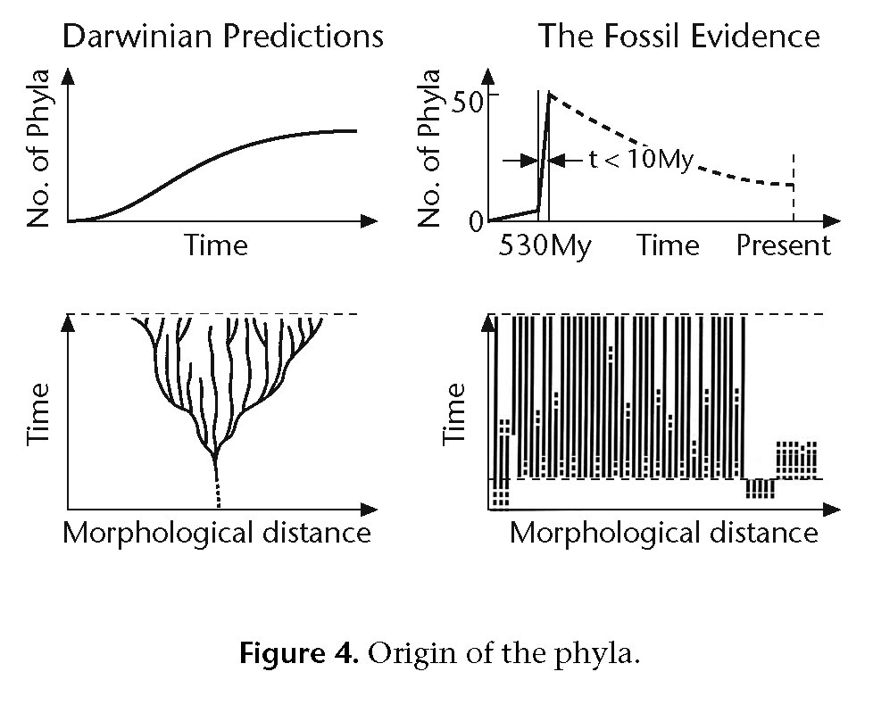

Rather than observing one body plan branching out into greater numbers of body plans over geologic time, paleontologists instead note maximum disparity10 between body plans from the beginning, and the retention of essential characters within each throughout geologic history, while increasing diversification occurs at successively lower hierarchical levels; (VALENTINE 1986; PADIAN/CLEMENS 1985; BERGSTRÖM 1994). Developmental geneticist Stuart KAUFFMAN sees deeper reasons for the pattern than anything neo-DARWINISM knows: “the patterns of the branching, dramatic at first, then dwindling to twiddling with details later, are likely to be lawful” (KAUFFMAN 1995, p14).

After listening to CHEN’s “top-down” talk, paleontologist David BOTTJER said, “I think the Cambrian explosion is going to tell us something different about evolution, in the sense that it’s not the same story that we have always been taught” (BOTTJER personal communication). BOTTJER can’t argue with the top-down pattern: “After the concentration of phyla first showing up in the Cambrian”, he said, “then we see classes, then orders, families, and that’s where much of the action is later on, after the Cambrian. So there is that kind of a pattern. And the question is, why is that happening?” Participants in the Kunming symposium came prepared to propose new, sometimes non- DARWINIAN mechanisms to explain the relatively abrupt appearance of the phyla.

New explanations included: saltatory evolution as a reaction to submarine hydrothermal eruptions (YANG et al. 1999); a “Cambrian substrate revolution” in which burrowing animals destroyed the microbial mat habitat of others, resulting in new environments and extensive adaptations (BOTTJER 1999); a billion years of genetic preadaptations for complex metazoans through “set-aside cells” (DAVIDSON 1999); “intelligent design”, the inference that the preadaptations and “appearance of design” point to an actual design by an intelligent entity, whether that entity be explained by directed panspermia, a Platonic demiurge, a theistic deity, or some other, unknown intelligent cause (NELSON 1999; WELLS 1999); the evolution of Platonic forms as a vitalistic process, i.e., the suggestion that evolution is driven by a controlling force or principle within organic forms that cannot be reduced to physics and chemistry alone (DENTON 1999); and top-down evolution, in which laws of harmony play at least as great a role in evolution as competition (CHEN 1999).

Contingency
Returning to our original three hypotheses, we now ask: How do findings surrounding the earliest known craniate affect probabilities for the evolution of cognition? Cephalization prior to the development of an internal body support structure might suggest a body plan in which the head is in some sense dominant. Observing the top-down pattern in the subsequent fossil record, some might further see in this a law-like process dictating an early appearance of brainy chordates among the body plans. But what kind of natural law would demand that, of all the evolving phyla, one of them would necessarily develop a conspicuous brain, ready to be subsequently supported by the vertebrate structure?

Worse, what kind of law would demand that such a pre-backbone craniate would necessarily survive what Stephen Jay GOULD calls “the Burgess decimation”? (GOULD 1989, pp233–239). In Wonderful Life, he suggests that “a 90 percent chance of death would be a good estimate for major Burgess [Cambrian] lineages” (p47). In recent years, Peter WARD and Donald Brownlee have stirred up controversy about the odds against complex life (even as complex as a flatworm) evolving on another planet. In their book Rare Earth, they argue that complex life in the galaxy may be rare, mainly because of the small number of planets that provide enough time and the right conditions for its evolution (WARD/ BROWNLEE 2000). They also believe that the Cambrian explosion of so many new, widely separated, complex animal groups didn’t have to happen. Neo- DARWINISM doesn’t predict such an event. And the fact that virtually no new animal phyla have evolved in the 530 million years since should give us pause (VALENTINE 1995).

The new discoveries in China take this concern a step further, demonstrating that even a “charmed place” like Earth, apparently ideal for life, is not necessarily good enough to produce advanced intelligence. First we learn that chordates, like the other animal phyla, must evolve early to evolve at all (since new phyla don’t keep appearing after the Cambrian). Then we learn that major groups did not survive the Cambrian, though we know of no reason why they were less fit than chordates. The first fact (all body plans forming close together in time) has a law-like quality about it, while the second (extinctions) appears highly stochastic.

GOULD may have been overenthusiastic in his use of the term “Cambrian decimation” (GOULD 1989, p47), and we should not infer that chordates only had once chance in ten to survive the Cambrian. To say that most lineages disappeared is not to say that most phyla disappeared. We do not know that the Cambrian ended with a massive extinction event, as we do about the end of five other periods. However, some analyses show that more disappearances occurred by the end of the Cambrian than at the end of any of the “Big Five” extinctions (WARD/BROWNLEE 2000, p184)—even the Permian, usually declared to be the most catastrophic. According to independent studies by paleontologists Helen Tappan and Norman Newell, about 60 percent of marine families went extinct in the Cambrian, compared to about 55 percent in the Permian” (Ibid).

What we can say with certainty is that craniates had their birth in the most dangerous possible period in the history of metazoan life. As has long been known, in only one period do the number of animal phyla decrease: the Cambrian, and in that period they decrease drastically (DOBZHANSKY et al. 1977, pp421–23). Cambrian researchers say that this period was by far the riskiest because species diversity within each phylum was at an all-time low, making it easier for changing environmental conditions to destroy an entire phylum merely by eliminating a few species (GOULD 2002, p1315). But as geologic time progresses, there is a pattern of increasing diversity at lower taxonomic levels relative to the higher taxa. Today there are far fewer classes and orders than existed four- to five-hundred million years ago, while there are probably eight to ten times the number of species (Dobzhansky et al. 1977, p428).

Thus the same phenomenon that gives rise to the top-down pattern in the fossil record also helps to explain why GOULD considered the chordate’s Cambrian survival a momentous event, like winning the lottery. And what reason can we give for expecting our winning streak to hold up through all the subsequent chancy events, including at least five major extinctions? Perfectly fit species were caught by chance at the wrong time, belonging to groups that would not otherwise have gone extinct, but that simply happened to be at a low point in species numbers (since species numbers fluctuate randomly over time) (GOULD 2002, pp1312–1317). The K-T impact that was apparently ultimately responsible for exterminating the dinosaurs 65 million years ago happened to work in favor of small mammals. But what if that extraterrestrial impactor had missed the Earth? Might dinosaurs have ruled the planet for another 200 million years, preventing the evolution of cognition?

The Principle of Mediocrity
Such an idea appears to challenge the Principle of Mediocrity (also known as the Copernican Principle), the assumption that there is nothing special about our place in the universe. After all, the universe does not revolve around Earth. Our planet, our solar system, even our galaxy is but one of billions. Applied to our subject, the Principle of Mediocrity implies that if human-level cognition exists here, it must exist commonly throughout the universe.

What astronomers know by principle and by multiple proofs, biologists are anxious to demonstrate too. Suspecting that we self-aware beings shouldn’t be exceptional, biologists and paleontologists are beginning to contemplate new ways to beat the odds. A few even wonder if the game is somehow rigged. This seems to be Jun-Yuan CHEN’s position, and a theme of his “top-down” talk at the Kunming conference: the fossil record demonstrates something more than accidental progress by a series of flukes.

Rather than seeing a gradual accumulation of small modifications that finally added up to widely separated animal groups, CHEN observes an explosive appearance of particular forms—sophisticated, widely separated animal groups, right from the start. Diagnostic characters did not accrue over time, but showed up with their first appearance in the form of Bauplans, including our own (CHEN 1999; BERGSTRÖM 1994). To say that this was not in some sense “meant to be” would seem to be a denial of this important, Copernican axiom of science.

Cognition in Other Body Plans?
Haikouella demonstrates that the basic body plan that sets us so far apart from mollusks and arthropods was in place at the beginning of the animal fossil record. Chordates, named for the notochord that would eventually be largely replaced and surrounded by the vertebral column, seem ideally suited to provide the structure required to put sensory organs up high, where they can help an animal get the best perspective on surroundings. Other design requirements for brainy wannabees naturally follow: the brain needs to be near these sensory organs, to minimize reaction time, and the whole should be protected by an encasement. A distinct head is thus a part of the package, which CHEN and SHU claim to have found in these earliest “craniates”. But again, the very considerations that make this animal appear to be optimally placed also make its position look tenuous.

Consider a world where chordates had gone extinct with other Cambrian animals. GOULD considers this to be a likelier scenario, a world without fish, birds, reptiles and mammals. Instead, lots of sea stars, crustaceans, insects, and worms. But, we ask, couldn’t chordates have re-evolved later? Not when we recall that, with the possible exception of Bryozoa (“moss animals”), no new animal phylum has ever evolved since the Cambrian period (VALENTINE 1995). If advanced intelligence was to evolve after that, it would have had to take a radically different form.

In that case, wouldn’t another animal group have filled our niche to eventually develop the ability to compose literature and do math? Again, not likely. Biologists have reasons to doubt that other phyla are so well suited to developing large brains situated in a commanding position. For a simple thought experiment, readers should try to picture a sea star, bug or worm with a big head. Or, more to the point, readers might try to think of a member of a non-chordate phylum on this planet that did develop a written language and technology, given 500 million years to do so.

Paleobiologist Michael BENTON points out that “the vertebrate design lends itself to the development and protection of a brain. This organ is present in other animals, but there are limits on its growth—one of them imposed very early in the history of life, when animals were first developing basic equipment like a front and a back, sense organs, and the ability to use information from the sense organs …” (BENTON 1993). BENTON notes the importance of the right architecture to create space available for the cluster of nervous tissue where data arrive and orders depart. While vertebrates separate this central ganglion from the rest of the body, arthropods and mollusks wrap it around their gut. Observes BENTON: “Any tendency for this tissue to grow is likely to squeeze the tube of the gut and constrict the supply of food. This is a contradiction that the arthropod design has never resolved…” (Ibid).

What if chordates survived, but not mammals or primates? Some might argue that, given more time, dinosaurs themselves could have developed high intelligence. Paleobiologists, however, say that a wholly different kind of skull would be required. “You cannot simply grow a giant brain in a dinosaur like Velociraptor: you have to reconstruct the skull”, writes Richard FORTEY. “Consciousness is not a clever trick to be whipped up from any set of neurons like a soufflé from an egg” (FORTEY 1998).

Partly because our present existence appears to depend upon a long string of unpredictable accidents, biologists know of no fundamental “law of progress” to show them why the path should have led to anything like Homo sapiens. Biologist C. O. LOVEJOY writes that “the evolution of cognition is the product of a variety of influences and preadaptive capacities, the absence of any one of which would have completely negated the process” (LOVEJOY 1981). He notes that the human’s complex nervous system is actually a reproductive liability, requiring a longer gestation period and a longer time to train the young. LOVEJOY concludes: “It is evident that the evolution of cognition is neither the result of an evolutionary trend nor an event of even the lowest calculable probability, but rather the result of a series of highly specific evolutionary events whose ultimate cause is traceable to selection for unrelated factors such as locomotion and diet” (Ibid).

“If intelligence has such high value”, writes Ernst MAYR, “why don’t we see more species develop it?” (MAYR 1996). He contrasts the singular development of high intelligence with the repeated evolution of sight, which occurred at least 40 times (SALVINI-PLAWEN/MAYR 1977). He calls the search for extraterrestrial intelligence “hopeless” and “a waste of time”, concluding that “for all practical purposes, man is alone” (MAYR 2001, p263).

The list of leading biologists and paleontologists on record for defending this intelligence-by-fluke position is impressive, including SIMPSON, DOBZHANSKY, FRANCOIS, AYALA, and GOULD (BARROW/ TIPLER 1986, p133). British astronomer John BARROW and American physicist Frank TIPLER note that “there has developed a general consensus among evolutionists that the evolution of intelligent life, comparable in information-processing ability to that of Homo sapiens, is so improbable that it is unlikely to have occurred on any other planet in the entire visible universe” (Ibid).

Many astronomers who once took optimistic positions on the probability of finding signals from an extraterrestrial intelligence are adjusting their predictions. Forty years of null SETI results may have even taken their toll on optimist Robert JASTROW, director of the Mt. Wilson Observatory. Though he once told this writer, “We’ll be hearing from those guys soon”, he has since modified his statement to “If life is common, we’ll be hearing from those guys soon” (JASTROW personal communication). Even this guarded claim shows an astronomer’s willingness to believe that the route from life to intelligence is an obvious one, which, as we have seen, is disputed by most biologists and paleontologists schooled in the Modern Synthesis.

Something Missing
Some paleontologists see such strong trends in the fossil record that they don’t believe contingent events can overcome them. Jun-Yuan CHEN believes that there must be other forces driving evolution toward intelligence besides natural selection and mutations. If evolution were restricted to these two forces, he says, then all life would still be microbial. “Bacteria are very successful”, pointed out CHEN. “They have a great capacity to adapt to environmental changes” (personal communication). And he noted that bacteria have flourished better than other life forms that have come and gone over billions of years without complexity or intelligence. Complex life, CHEN said, is less capable of making adaptations, so that “complex, highly evolved life, like the human, has no reason to appear. So why should these chance mutations plan such complex types of animals?” (Ibid). What’s missing from neo-DARWINISM?

Wallace ARTHUR pictures neo-DARWINIAN theory as a grand edifice with foundations and walls that are composed of interdependent disciplines, so that “if one part turns out to be wrong, the whole structure may eventually collapse” (ARTHUR 1997, p285). Until the developmental component has made its contribution, he says, “There is not just a brick or two missing, but rather a whole section of the building” (Ibid).

Physicist Paul DAVIES suspects that biologists have concluded too rashly that they understand life’s origin and evolution, and that “we are missing something very fundamental about the whole business” (DAVIES 1999, p17). Cosmologists routinely use the term “anthropic principle” to describe the many preconditions for complex life met by severely constricted universal constants (BARROW/TIPLER 1986; BARROW 2002; GREENE 1999). These include the apparent “fine-tuning” of the universe’s expansion rate (sometimes calculated to be “tuned” to one part in 1060 at one second after the big bang, as a precondition for life) (HAWKING 1988, pp121–122; KRAUSS 1998) and the precise strengths of nature’s four fundamental forces (e.g., the strength of the electromagnetic force appears to be tuned relative to the gravitational force to at least one part in 1036, as a precondition for the existence of stable stars) (BARROW/ TIPLER 1986, p219; DAVIES 1983, p188; REES 1999, p2). DAVIES has long wondered if biologists would see the constraints and the bio-friendly pattern too.

CONWAY MORRIS sees something like it: “Consider, for example, the sponges”, he writes, “which by general consent are the most primitive living metazoans. Nevertheless, their biochemistry includes elements that seem to foreshadow the immune system of vertebrates” (CONWAY MORRIS 2000; SCHÄCKE et al. 1994). Though sponges do not have nerve cells, they already have neuronal-like receptors, so that they “seem to be almost ‘animals in waiting’” (CONWAY MORRIS 2000). CONWAY MORRIS believes that caution is in order and that such findings can be carried too far, producing a distorted view; yet he continues listing examples of what appear as preadaptations, such as the nervous system of amphioxus revealing “a vertebrate in waiting” (Ibid).

Similarly, recent genetic studies of hemichordates, which have no brains, show that these most plausible models for proximate ancestors to chordates already contain the genes that express the brain and spinal cord in vertebrates (LACALLI 2003). Hemichordate genes that are responsible for patterning the body along its front-to-back axis were found expressed in the surface tissue in a nearly identical arrangement to those that express themselves in vertebrate brains and spinal chords (LOWE et al. 2003). LOWE et al. favor the idea that a complex genetic map was in place long before the complex morphology.

The bottom line, according to CHEN, is that the standard mechanisms of neo-DARWINISM offer no basis for a “ladder of progress”. So far, a noncontroversial view. But if his “top-down” alternative gains acceptance, it would create a paradigm shift in biology. His replacement of competition with harmony and top-down evolution could be taken to suggest the first rungs in such a guiding ladder. CHEN’s discovery of Haikouella shows that the last really big turn in the pathway to humanity did not occur at the end of the evolutionary process, but at the beginning. Does this mean that the “goal” of humanity was set from the beginning of metazoan life? Few other participants at the Kunming conference were willing to say anything like that. But some did, including New Zealand geneticist Michael DENTON.

Arguing from the fact that almost no new phyla evolved after the Cambrian explosion, DENTON said: “The body plans of the Cambrian are probably built into nature from the beginning” (DENTON 1999). DENTON is part of a team that recently revealed how, at its base, life follows “laws of form” in the discrete, three-dimensional folding patterns of protein molecules. The folds can be classified into a finite number of structural families that are determined by natural law, not natural selection—much like the physical laws that give rise to atomic elements in the periodic table. Writing for the Journal of Theoretical Biology, his team describes the protein folds as “‘lawful forms’ in the Platonic and pre-DARWINIAN sense of the word, which are bound to occur everywhere in the universe where the same 20 amino acids are used for their construction” (DENTON/MARSHALL/ LEGGE 2002). In another piece, for Nature, DENTON and MARSHALL argue: “If forms as complex as the protein folds are intrinsic features of nature, might some of the higher architecture of life also be determined by physical law?” (DENTON/MARSHALL 2001).

Moreover, given the limitations of a material world of flux, DENTON considers the possibility that “the laws of nature are fit for only one unique thinking being capable of acquiring knowledge and ultimately comprehending the cosmos” (DENTON 1998). He cites Mark WARD’s research on the fine balance achieved (1) between the size/number of neurons and the blood vessels which nourish them, and (2) between the width of axons and the required insulation/ blood supply (WARD 1997). Referring to this and to the staggering compaction of synaptic connections in the human brain, he writes that “the evidence is certainly consistent with the possibility that the human brain does indeed represent the most advanced information-processing device that can be built according to biological principles” (DENTON 1998).

However, to say that the experience of consciousness is fully explained by the physical laws that produce such a brain is a non sequitur, except to committed reductionists. Physicists from Brian PIPPARD to Stephen WEINBERG have raised questions about the reasonableness of expecting consciousness itself11 to ever be subsumed under the domain of physics and chemistry (PIPPARD 1992; WEINBERG 1992, p44). Given a complex structure with ample computing power, should a theoretical physicist be able to deduce the existence of self-awareness from laws of physics? Cognitive scientist David J. CHALMERS suggests that the problem of trying to derive consciousness from physical laws is so troublesome that any final theory of physics “must contain an additional fundamental component”. He proposes “that conscious experience be considered a fundamental feature, irreducible to anything more basic” (CHALMERS 1995).

Concluding Options
If nature is somehow rigged in favor of mind, then the tremendous odds against our existence disappear. But if that concept were to catch hold in scientific circles, Paul DAVIES claims that it would create a “decisive shift” in science (DAVIES 1999, p263), reversing a 300-year trend toward reductionist thinking. We cannot at the same time hold to the Principle of Mediocrity and to the idea that human cognition is a bizarre case.

The evidence surrounding the discovery of the earliest craniates forces us to choose between renouncing one of two deeply embedded traditions of modern science. Either mind plays a role in nature by necessity, which appears to contradict the reductionist basis for doing science—or mind plays no role and has appeared as an “oddball rarity”, which contradicts science’s equally cherished Copernican Principle. This means that our first two original options —human-level cognition as either an accidental, or a law-like, process—will give us serious problems either way we choose. If we choose the lawful process option, we must then ask ourselves: What kind of law will ensure that primates (or any other form preadapted for braininess) will survive through the bottleneck of contingent events that are beyond the control of any known natural mechanisms?

To opt for human-level cognition as both accidental rarity and commonplace occurrence is to render both options meaningless, since they contradict each other. We do have a third option: that our existence is primarily due to neither accident nor cosmic law. To speak awkwardly, as we did at the beginning of this article, of the human-level cognition “observed” on Earth is to flagrantly ignore our own unique position as both observer and the observed. The inside information we’re privy to as conscious and frequently conscientious primates may provide some hints about the workings of chance and natural law, for our lives would seem to be, from our own viewpoints, composed of more than either accidents or laws. From an unlikely combination of circumstances have emerged beings who are much more than the sum of their parts. It would seem that our most uniquely human abilities are not predictable in any detail from our morphologies.

If we say that we transcend our physical world with our human achievements—our music, literature, humor, love—it still remains for us to decide whether this transcendence emerged by accident or according to a prior purpose. Simon CONWAY MORRIS suggests that this may be the principal reason that biologists have hesitated so long to explore directionality and channeling: “If evolution is in some sense channeled, then this reopens the controversial prospect of a teleology; that is, the process is underpinned by a purpose”. (CONWAY MORRIS 1998, p14). And he notes a growing trend to bring cosmology’s Anthropic Principle down to our biosphere. CONWAY MORRIS sees humanity’s uniqueness in our ability to make these kinds of choices— and voices his irritation with those who choose to live irresponsibly based on an assumption of life’s purposelessness (Ibid). The reductionist’s belief in human life as a cosmic accident is a metaphysical commitment too.

After all, at least to this point, the most dazzling thing on Earth that evolution has done is to produce volitional beings whose present lives have little to do with the physical processes that brought them. “Uniquely”, CONWAY MORRIS writes, “there is inherent in our human situation the possibility of transcendence” (Ibid). The fact that it’s only a possibility speaks volumes, once again, about the human capacity to choose.

Acknowledgements
I wish to thank the referees for providing many useful suggestions for improvement of this manuscript. I also thank Jun-Yuan CHEN, Nanjing Institute of Geology and Palaeontology, and Paul K. CHIEN, University of San Francisco, for generously contributing photographic materials and diagrams.

Notes
1 Biological dictionaries now frequently replace the subphylum name Vertebrata by the newer, broader phylum name Craniata in order “to represent the distinguishing characteristics more accurately” (RUDIN 1997). Chief among craniate distinctions is a manifest head containing a brain and sensory organs. Modern craniates are also characterized, as vertebrates were, by a segmented vertebral column. The group continues to include fish, amphibians, reptiles, birds, and mammals. In modern cladograms, the Chordata clade includes the Craniata clade, the Craniata clade includes the Vertebrata and Myxinoidea clades, etc.
2 The following distinction is made here between cognition and intelligence: Cognition is used to describe the application of mental processes involved in knowledge; while intelligence describes the ability to know, regardless of its use. Cognition is the act of using of one’s intelligence. Thus the human capacity for thought and reason called intelligence results in human-level cognition, an awareness involving reasoning and judgment apparently unlike the mental processes of any other animal on this planet. Human- level cognition should be detectable, since it tends to find expression in human-level communication, engineering feats, abstract and mathematical problem-solving, musical compositions, fine art, literature, science, etc.
3 That is, the evolution of human-level cognition is dependent upon a long series of unpredictable, historical events, making its occurrence on Earth a rarity. If other planets harbor life, only a very tiny fraction, if any, would then be expected to host human-level-or-higher cognition.
4 One might argue for a fourth option: that human-level cognition exists as both a rare fluke and a common or lawlike property of the universe; but the statements can both be true only by rendering them meaningless. While there is nothing logically contradictory about chance mutations (flukes) and natural selection (law) working together to produce novel forms of life, the question here is whether it is rare or common for any such combination of law and chance to produce forms that result in human-level cognition. When referring to the evolution of cognition, the first two hypotheses are contradictory and do not allow for both as a primary cause.
5 The terms body plan and Bauplan are generally used interchangeably. James VALENTINE applies the term Bauplan to “the upper levels of the taxonomic hierarchy” where “phyla- or class-level clades are characterized by their possession of particular assemblages of homologous architectural and structural features” (VALENTINE 1986). Wallace ARTHUR identifies six morphological characters to distinguish animal body plans: skeleton, symmetry, pairs of appendages, body cavity, cleavage pattern, and segmentation (ARTHUR 1997, p27). Like others, ARTHUR tends to identify animal body plans in the Cambrian period with the animal phyla (he speaks of the Cambrian “origin of the 35 or so animal body plans” (ARTHUR 1997, opening page), though in more general contexts (non-Cambrian) he speaks of “phylum/ class level body plans” (ARTHUR 1997, p27).
6 Developmentalism: emphasizes the importance of understanding ontogeny—the history of, and the genetic processes involved in, the development of the individual organism—for understanding evolution. Neo-DARWINISM: emphasizes natural selection and mutations as the overwhelming driving forces for understanding evolution. Also called the Modern Synthesis (since it synthesizes these two mechanisms). Formalism: emphasizes internal constraints toward the evolution of particular body forms. Functionalism: emphasizes external adaptations as the primary force behind the production of characters that function best in particular environments. Punctuationalism: emphasizes the geologically abrupt origin and subsequent stasis (“equilibrium”) of most species. Gradualism: emphasizes the slow and constant accretion of small changes that eventually add up to larger changes and separations between organisms. Top-down theory: emphasizes the evolution of the higher taxa first, so that the most widely separated groups appear early, and “the diversification of the phyla occurs before that of classes, classes before that of orders, orders before that of families” (ERWIN/VALENTIN/SEPKOWSKI 1987). Bottom-up theory: emphasizes the evolution of the higher taxa from the accumulation of lower taxa, creating a phylogenetic tree of increasing diversity and eventual disparity.
7 Reductionism is a philosophical method of explaining a complex set of facts by reducing them to a set of smaller, simpler facts; the whole should be predictable from its smaller, constituent parts.
8 Constraints may be negative or positive; negatively, they are restrictions on evolution’s direction; positively, they are preferred directionality of variation; either internal or external factors may constrain evolution toward particular forms. Channels are usually positive, internal, preferred evolutionary pathways.
9 Convergence is the explanation for shared characters of independently evolved organisms. In GOULD’s lexicon, the convergence of characters is based upon common external adaptations. He carefully distinguishes convergence from parallelism, which is the independent origin of common features channeled by internal constraints of homologous genes or developmental pathways. Other scientists frequently employ the term convergence to include any case where the evolution of characters repeats itself, whether explained by external constraints or internal channeling.
10 Disparity is the word usually used to describe differences between organisms that involve whole body plans; diversity is reserved for differences between lower-taxa organisms, especially at the species level (GOULD 1989, p49).
11 WEINBERG distinguishes between “consciousness itself”, the self-awareness/feelings experienced by humans, and “correlatives to consciousness” that may be examined in terms of brain waves, electrical activity, hormones in the blood, etc. (WEINBERG 1992, p44).

References
Arthur, W. (1988) A Theory of the Evolution of Development. Wiley: Chichester UK.
Arthur, W. (1997) The Origin of Animal Body Plans. Cambridge University Press: Cambridge UK.
Barrow, J.D. (2002) The Constants of Nature. Pantheon Books: New York.
Barrow, J. D./Tipler, F. J. (1986) The Anthropic Cosmological Principle. Oxford University Press: Oxford/New York.
Benton, M. (1993) The rise of the fishes. In: Gould, S. J. (ed) The Book of Life. W. W. Norton & Company: New York, pp. 65–77.
Bergström, J. (1994) Ideas on early animal evolution. In: Bengston, S. (ed) Early Life on Earth, Nobel Symposium no. 84. Columbia University Press: New York, pp. 460–466.
Bottjer, D. J. (1999) The Cambrian substrate revolution and the origin and evolution of the mollusca. Presented at the International Symposium of the Origin of Animal Body Plans and their Fossil Records, Kunming, China, June 20– 25, 1999 (Sponsored by the Early Life Research Center and the Chinese Academy of Sciences).
Chalmers, D. J. (1995) The puzzle of conscious experience. Scientific American 273: 80–86.
Chen, J.-Y. (1999) Top-down evolution and the fossil evidence. Presented at the International Symposium of the Origin of Animal Body Plans and their Fossil Records, Kunming, China, June 20–25, 1999.
Chen, J.-Y., Dzik, J./Edgecombe, G. D./Ramsköld, L./Zhou, G.- Q. (1995) A possible Early Cambrian chordate. Nature 377: 720–722.
Chen, J.-Y./Huang, D.-Y./Li, C.-W. (1999a) An early Cambrian craniate-like chordate. Nature 402: 518–522.
Chen, J.-Y./Huang, D.-Y./Li, C.-W. (1999b) An early Cambrian new chordate casting new light on the origin of craniate. Presented at the International Symposium of the Origin of Animal Body Plans and their Fossil Records, Kunming, China, June 20–25, 1999.
Conway Morris, S. (1998) The Crucible of Creation: The Burgess Shale and the rise of animals. Oxford University Press: Oxford/New York.
Conway Morris, S. (1998–1999) The challenge: Showdown on the Burgess Shale. Natural History 107: 48–55.
Conway Morris, S. (2000) Evolution: Bringing molecules into the fold. Cell. 100: 1–11.
Conway Morris, S./Whittington, H. B. (1979) The animals of the Burgess Shale. Scientific American 240: 131.
Darwin, C. (2000) On the Origin of Species by Means of Natural Selection. Harvard University Press: Cambridge MA. Originally published in 1859.
Davidson, E. (1999) Regulatory control of embryological development and the evolutionary origin of animals. Presented at the International Symposium of the Origin of Animal Body Plans and their Fossil Records, Kunming, China, June 20–25, 1999.
Davies, P. (1983) God and the New Physics. Simon and Schuster: New York.
Davies, P. (1999) The Fifth Miracle. Simon & Schuster: New York.
De Beer, G. R. (1930) Embryology and Evolution. Oxford University Press: Oxford UK.
Dennett, D. C. (1996) Darwin’s Dangerous Idea: Evolution and the Meaning of Life. Penguin Books: London.
Denton, M. J. (1998) Nature’s Destiny. The Free Press: New York.
Denton, M. J. (1999) The nature and evolution of biological form. Presented at the International Symposium of the Origin of Animal Body Plans and their Fossil Records, Kunming, China, June 20–25, 1999.
Denton, M. J./Marshall, C. J. (2001) Laws of form revisited. Nature 410: 417.
Denton, M. J./Marshall, C. J./Legge, M. (2002) The protein folds as platonic forms: New support for the pre-Darwinian conception of evolution by natural law. Journal of Theoretical Biology. 219(3): 325–342.
Dobzhansky, T./Ayala, F./Ledyard Stebbins, G./Valentine, J. (1977) Evolution. W.H. Freeman & Co: San Francisco.
Donovan, S. K./Paul, C. R. C. (eds) (1998) The Adequacy of the Fossil Record. Wiley: Chichester UK.
Dzik, J. (1995) Yunnanozoon and the ancestry of chordates. Acta Paleontologica Polonica, 40: 341–360.
Enserink, M. (1999) Fossil opens window on early animal history. Science 286: 1829.
Erwin, D. H./Valentine, J. W./Sepkowski, J. J. (1987) A comparative study of diversification events: the early Paleozoic versus the Mesozoic. Evolution 41: 1183.
Foote, M. (1996) On the probability of ancestors in the fossil record. Paleobiology 22(2): 141–151.
Foote, M./Sepkoski, J. J. Jr. (1999) Absolute measures of the completeness of the fossil record. Nature 398: 415–417.
Fortey, R. (1998) Shock lobsters. Book review of “The Crucible of Creation: The Burgess Shale and the Rise of Animals” by S. Conway Morris. London Review of Books 20(19).
Goodwin, B. (1994) How the Leopard changed Its Spots: The Evolution of Complexity. Weidenfeld & Nicholson: London.
Gould, S. J. (1977) Evolution’s erratic pace. Natural History 86: 12–16.
Gould, S. J. (1989) Wonderful Life: The Burgess Shale and the Nature of History. W. W. Norton & Company: New York/ London.
Gould, S. J. (1996–1997) War of the worldviews. Natural History 105: 22–33.
Gould, S. J. (1997) Darwinian fundamentalism. The New York Review of Books 44(10): 2–4.
Gould, S. J. (2002) The Structure of Evolutionary Theory. Harvard University Press: Cambridge MA.
Greene, B. (1999) The Elegant Universe: Superstrings, Hidden Dimensions, and the Quest for the Ultimate Theory. W. W. Norton & Company: New York.
Hall, B. G. (1992) Evolutionary Developmental Biology. Chapman & Hall: London.
Hawking, S. W. (1988) A Brief History of Time: From the Big Bang to Black Holes. Bantam: New York.
Holland, N. D. (1999) Bringing the chordate ancestor of the vertebrates into focus: A decade of progress in neontology and paleontology. Presented at the International Symposium of the Origin of Animal Body Plans and their Fossil Records, Kunming, China, June 20–25, 1999.
Kauffman, S. A. (1995) At Home in the Universe: The Search for Laws of Self-Organization and Complexity. Viking- Penguin: London.
Krauss, L. M. (1998) The end of the age problem, and the case for a cosmological constant revisited. Astrophysical Journal 501: 465.
Lacalli, T. (2003) Body plans and simple brains. Nature 424: 263–264.
Lewin, R. (1988) A lopsided look at evolution. Science 242: 292.
Li, C.-W. (1999) In: Chiu, Y.-T. Fossil discovery changes theory. The Taipei Times, December 2, 1999.
Li, C.-W./Chen, J.-Y./Tsu, E. H. (1998) Precambrian sponges with cellular structures. Science 279: 879–882.
Lovejoy, C. O. (1981) Evolution of man and its implications for general principles of the evolution of intelligent life. In: Billingham, J. (ed) Life in the Universe. MIT Press: Cambridge MA, pp. 317–329.
Lowe, C. J./Wu, M./Salic, A./Evans, L./Lander, E./Stange-Thomann, N./Gruber, C. E./Gerhart, J./Kirschner, M. (2003) Anteroposterior patterning in hemichordates and the origins of the chordate nervous system. Cell 133: 853–865.
Lynch, M. (1999) The age and relationships of the major animal phyla. Evolution 53(2): 319–324.
Mayr, E. (1996) The search for extraterrestrial intelligence: Scientific quest or hopeful folly? A debate between Ernst Mayer and Carl Sagan. Planetary Report 9(3): 4–14.
Mayr, E. (2001) What Evolution Is. Basic Books: New York.
Monastersky, R. (1999) Waking up to the dawn of vertebrates. Science News 156: 292.
Nelson, P. A. (1999) Generative entrenchment and body plans. Presented at the International Symposium of the Origin of Animal Body Plans and their Fossil Records, Kunming, China, June 20–25, 1999.
Padian, K./Clemens, W. A. (1985) Terrestrial vertebrate diversity: Episodes and insights. In: Valentine, J. W. (ed) Phanerozoic Diversity Patterns: Profiles in Macroevolution. Princeton University Press: Princeton, pp. 41–96.
Pippard, B. (1992) Review of “Understanding the present: Science and the soul of modern man”, by B. Appleyard. Nature 357: 29.
Purnell, M. A./Donoghue, P. C. J. (1997) Architecture and functional morphology of the skeletal apparatus of ozarkodinid conodonts. Philosophical Transactions of the Royal Society of London, Series B 352: 1545–1564.
Raff, R. A./Kauffman, T. C. (1983) Embryos, Genes and Evolution: The Developmental-Genetic Basis of Evolutionary Change. Macmillan: New York.
Rainey, P. (2003) Review of “Evolution: Five big questions”, by M. Russell/A. Pomiankowski/G. Turner/P. Rainey/R. Dunbar. New Scientist, June 14, p. 32.
Rees, M. (1999) Just Six Numbers: The Deep Forces that Shape the Universe. Basic Books: New York.
Rudin, N. (1997) Dictionary of Modern Biology. Barron’s Educational Series: New York.
Salvini-Plawen, L./Mayr, E. (1977) On the evolution of photoreceptors and eyes. In: Hecht, M. K./Steere, W. C./Wallance, B. (eds) Evolutionary Biology. Plenum: New York, pp. 207–263.
Schlosser, G. (2000) Amphibian variations: The role of modules in mosaic evolution. Presented at the 5th Altenberg Workshop on Theoretical Biology 2000, Konrad Lorenz Institut, Altenberg, Austria.
Schäcke, H./Rinkevich, B./Gamulin, V./Müller, I. M./Müller, W. E. G. (1994) Immunoglobin-like domain is present in the extracellular part of the receptor tyrosine kinase from the marine sponge Geodia cydonium. Journal of Molecular Recognition 7: 273–276.
Schmalhausen, I. I. (1949) Factors of Evolution: The Theory of Stabilizing Selection. Blakiston: Philadelphia PA.
Schwartz, J. H. (1999) Sudden Origins: Fossils, Genes, and the Emergence of Species. John Wiley: New York.
Shu, D./Conway Morris, S./Zhang, X.-L. (1996) A pikaia-like chordate from the lower Cambrian of China. Nature 384: 157–158.
Shu, D./Luo, H.-L./Conway Morris, S./Zhang, X.-L./Hu, S.-X./ Chen, L./Han, J./Zhu, M./Li, Y./Chen, L.-Z. (1999) Lower Cambrian vertebrates from south China. Nature 402:42– 46.
Shu, D./Zhang, X./Cheng, L. (1996) Reinterpretation of Yunnanozoon as the earliest known hemichordate. Nature 380:428–430.
Simpson, G. G. (1953) The Major Features of Evolution. Simon and Schuster: New York.
Simpson, G. G. (1960) The history of life. In: Tax, S. (ed) Evolution after Darwin. Volume 1: The Evolution of Life. University of Chicago Press: Chicago, pp. 117–180.
Simpson, G. G. (1961) Principles of Animal Taxonomy. Columbia University Press: New York.
Solé, R./Goodwin, B. (2000) Signs of Life: How Complexity Pervades Biology. Basic Books: New York.
Valentine, J. W. (1986) Fossil record of the origin of baupläne and its implications. In: Raup, D. M./Jablonski, D. (eds) Patterns and processes in the history of life. Springer-Verlag: Berlin, pp. 209–222.
Valentine, J. W. (1995) Why no new phyla after the Cambrian? Genome and ecospace hypotheses revisited. Palaios 10(2): 190–194.
Valentine, J. W./Erwin D. H. (1987) Interpreting great developmental experiments: The fossil record. In: Raff, R. A./ Raff, E. C. (eds) Development as an Evolutionary Process. Alan R. Liss: New York, pp. 71–107.
Waddington, C. H. (1957) The Strategy of the Genes. Allen & Unwin: London.
Ward, M. (1997) End of the road for brain evolution. New Scientist 153(2066): 14.
Ward, P. D./Brownlee, D. (2000) Rare Earth. Springer-Verlag: New York.
Weinberg, S. (1992) Dreams of a Final Theory. Pantheon: New York.
Wells, J. (1999) Resolving the paradox of homeotic genes in the origin of animal body plans. Presented at the International Symposium of the Origin of Animal Body Plans and their Fossil Records, Kunming, China, June 20–25, 1999.
Yang, W./Chen, N./Wang, X./Gao, L./Zhao, Y./Guo, Q. (1999) Saltatory evolution mechanism of the Weng’an biota. Presented at the International Symposium of the Origin of Animal Body Plans and their Fossil Records, Kunming, China, June 20–25, 1999.

